You’re Invited to an
Introduction to Essential Oils!
(Insert your catchy tag line here)
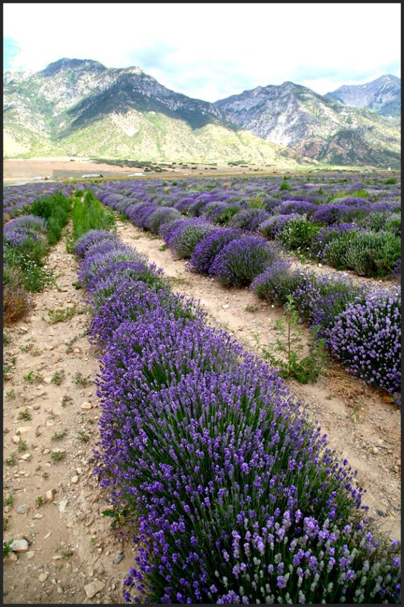
Date & Time:
April 12, 2014
1:00 pm - 3:00 pm

Location:
123 W. 1st Street
Littleton, CO 80100

Get the scoop on essential oils!
- Ease pain, depression and stress!
- Increase self-care without decreasing your time!
- Support healthy weight management goals!
- Stop flu and colds before they make you sick!

Learn the following methods
- Applying essential oils directly on the body using hands-on approach
- Using inhalation by spreading essential oils on the hands and breathing in the soothing aroma
- Dispersing the essential oil molecules into the air through diffusion

R.S.V.P. is REQUIRED as Space is Limited!
Reserve your spot by April 8th

Jane Jacob’s
111.111.1111
Email@EmailAddress.com

Bring a Friend and bond with a group that
loves to laugh and feel well!

