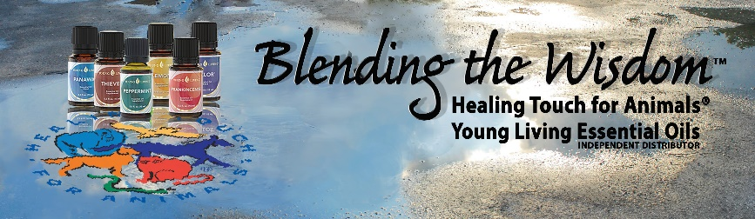

Join the Healing Touch for Animals® Young Living Team and start supporting the health & wellness of our animals and yourself!

The Premium Starter Kit is an extraordinary value that offers an array of oils and is the perfect option for those who are serious about transforming their lives.

The Premium Starter Kit includes a Dessert Mist Diffuser & 12 Essential Oils in 5 ml bottles.

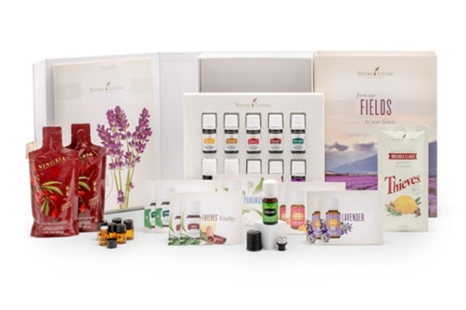
• Lavender
• Peppermint
• Lemon
• Citrus Fresh
• Frankincense
• Thieves®
• Raven
• DiGize™
• PanAway®
• Stress Away™
Only $165
• Valor®
• Peace and Calming®

Join the Healing Touch for Animals® Young Living Team and start supporting the health & wellness of our animals and yourself!

The Premium Starter Kit is an extraordinary value that offers an array of oils and is the perfect option for those who are serious about transforming their lives.

The Premium Starter Kit includes a Dessert Mist Diffuser & 12 Essential Oils in 5 ml bottles.

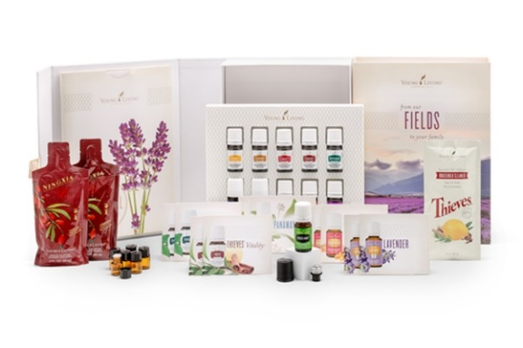
• Lavender
• Peppermint
• Lemon
• Citrus Fresh
• Frankincense
• Thieves®
• Raven
• DiGize™
• PanAway®
• Stress Away™
• Valor®
Only $165
• Peace and Calming®

Join the Healing Touch for Animals® Young Living Team and start supporting the health & wellness of our animals and yourself!

The Premium Starter Kit is an extraordinary value that offers an array of oils and is the perfect option for those who are serious about transforming their lives.

The Premium Starter Kit includes a Dessert Mist Diffuser & 12 Essential Oils in 5 ml bottles.

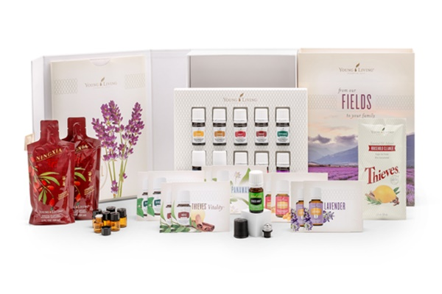
• Lavender
• Peppermint
• Lemon
• Citrus Fresh
• Frankincense
• Thieves®
• Raven
• DiGize™
• PanAway®
• Stress Away™
Only $165
• Valor®
• Peace and Calming®

Join the Healing Touch for Animals® Young Living Team and start supporting the health & wellness of our animals and yourself!

The Premium Starter Kit is an extraordinary value that offers an array of oils and is the perfect option for those who are serious about transforming their lives.

The Premium Starter Kit includes a Dessert Mist Diffuser & 12 Essential Oils in 5 ml bottles.

• Lavender
• Peppermint
• Lemon
• Citrus Fresh
• Frankincense
• Thieves®
• Raven
• DiGize™
• PanAway®
• Stress Away™
Only $165
• Valor®
• Peace and Calming®

Welcome to YOUR Team!

Order Online | Order by Phone
www.YoungLiving.com | 1.800.371.3515

Enroller:
Member #

Sponsor:
Member #

Contact HTA Anytime: 303.470.6572
YL@HealingTouchforAnimals.com

Welcome to YOUR Team!

Order Online | Order by Phone
www.YoungLiving.com | 1.800.371.3515

Enroller:
Member #

Sponsor:
Member #

Contact HTA Anytime: 303.470.6572
YL@HealingTouchforAnimals.com

Welcome to YOUR Team!

Order Online | Order by Phone
www.YoungLiving.com | 1.800.371.3515

Enroller:
Member #

Sponsor:
Member #

Contact HTA Anytime: 303.470.6572
YL@HealingTouchforAnimals.com

Welcome to YOUR Team!

Order Online | Order by Phone
www.YoungLiving.com | 1.800.371.3515

Enroller:
Member #

Sponsor:
Member #

Contact HTA Anytime: 303.470.6572
YL@HealingTouchforAnimals.com

