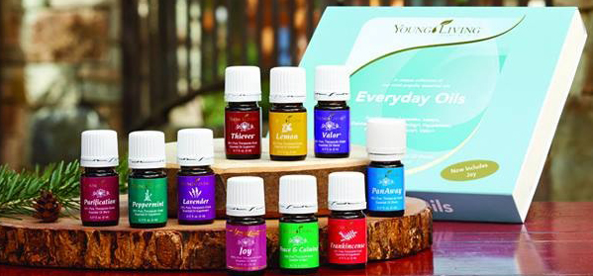
Dear Name,

Welcome to the HTA Young Living Team!
I personally chose Young Living essential oils because of the integrity used as the plants are planted, grown, harvested and bottled for distribution. This process assures me of the quality of the essential oils I receive from Young Living which leads to the healing and sense of well-being I have experienced from their use.
Take advantage of the many benefits your new Young Living membership offers, including wholesale discount prices and much more!
I highly recommend you consider Young Living’s Essential Rewards Program and earn points towards future product purchases with every order. All Essential Rewards orders qualify for reduced shipping costs – members pay a $6.98 U.S./$9.75 CAN flat shipping fee on an order's first five pounds.
The Essential Oils Desk Reference is an excellent resource, making it simple to find which essential oils are best to use for a given situation. The online resource is available through Life Science Publishing for $39.95.
I am committed to providing ongoing support to help you build your Young Living Team! Please feel free to call me with any questions at 123-123-1234; or you may contact Young Living Corporate at 1-800-371-3515.

Warmly,

