FREE Introduction to Essential Oils
(Insert your catchy tag line here)

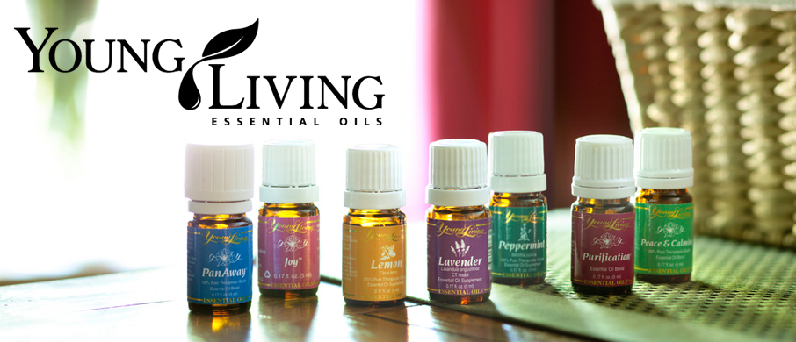

Learn about Young Living Essential Oils and how powerful plant extracts can help you and your family—including your pets—achieve
lifelong wellness and good health!

Using the following methods, learn how to use essential oils in your everyday life
- Applying essential oils directly on the body using a hands-on approach
- Using inhalation by applying essential oils on the hands and breathing in the soothing aroma
- Dispersing the essential oil molecules into the air through diffusion

Discover for yourself how to boost your spirits and
support physical health for you and your animals—naturally!

Date & Time:
July 26, 2014 from 1:00 pm – 3:00 pm

Location:
1000 S. 1st Street
Denver, CO 80200

Hosted By:
Jane Jacob’s
Email@EmailAddress.com
303.900.0000
Presented By:
Julie Jacob’s
Email@EmailAddress.com
303.901.0000
